4/14/14
Orientation for Student Teachers in Student Teaching seminar
Spring 2014

- Use the F-2 Application for Initial DC Educator License form at
http://education.cua.edu/res/docs/License/Application-for-DC-Educator-License-REGULAR-II-S12.pdf to apply for your teaching license.
- Use the F-5 Application for Teaching Endorsement at http://education.cua.edu/res/docs/kd-6-f5-osse-teaching-endorsement-app-vf-6-14-10.pdf if you plan to obtain licenses in additional areas in which you did not complete a program but passed the required PRAXIS II content and pedagogy tests.
- Once you graduate, CUA notifies DC’s Office of the State Superintendent of Education of your program completion. Having received all your application materials, OSSE will need 6-8 weeks to issue your teaching license.
- FBI background check info:
  - FBI check URL and list of locations: http://osse.dc.gov/sites/default/files/dc/sites/osse/publication/attachments/Non-DCPS%20Employee%20Background%20Check_7.30.2013.pdf

I’ll demonstrate in class how to submit ARP and EP assignments correctly in LiveText if requested.

The following are requirements for a DC standard (Regular II) license:
- Complete program (courses and all field experiences with at least a C-)
- Pass CORE/CASE (or PRAXIS I, or equivalent) as well as PRAXIS II content and pedagogy tests *Please note that CORE tests are the new requirement.
- Fill out license application form (see links above)
- Attach a $50 money order payable to Office of the State Superintendent of Education (OSSE)
- Have a background/FBI check (see link above)

Procedure for submitting application materials:
You will need to submit the following materials to DC’s Office of the State Superintendent of Education (OSSE):
- License application form (F2 and F5 if you apply for endorsements in additional areas)
- FBI check results
- $50 money order
- CORE/PRAXIS I and II test results. (If possible, mark OSSE or DCPS as an official score recipient so that they get all your licensure test scores.)

Forward completed application packet to:
Office of the State Superintendent of Education, Educator Licensure and Accreditation Unit, 810 1st Street, NE, 5th Floor, Washington, DC 20002.

The Department of Education will fill out a Program Completion/Licensure Recommendation Form to notify DC that you have completed the teacher education program. CUA will include your CORE/PRAXIS I (or equivalent) and PRAXIS II scores in the Program Completion/Licensure Recommendation Form we send to DC. Graduate candidates will have to provide information on their undergraduate degree on this form. Please contact Ms. Melisa Darby (darby@cua.edu, 202-319-5801) to give her this information.

Course Registration Information
Make sure you are registered for the right courses:

ECE:  - EDUC 400, 401, 402, 403  - EDUC 498 (Undergraduate Comprehensive Examination) | ELE:  - EDUC 400, 411, 412, 413  - EDUC 498 (Undergraduate Comprehensive Examination) | SEC:  - EDUC 461, 462, 463  - EDUC 498 (Undergraduate Comprehensive Examination)  - ENG 498 or MATH 498 or HIST 498 (Undergraduate Comprehensive Examination) – depending on your secondary teacher education major

PRAXIS II Content and Pedagogy Tests
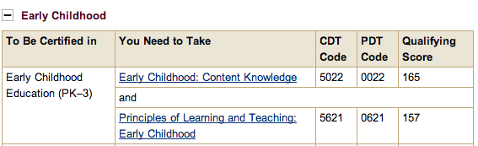
No need to take ELE content test for NCLB highly qualified status (ECE content test is sufficient for the qualifications.) Take ELE content and pedagogy tests only if you apply for endorsement in elementary education also.
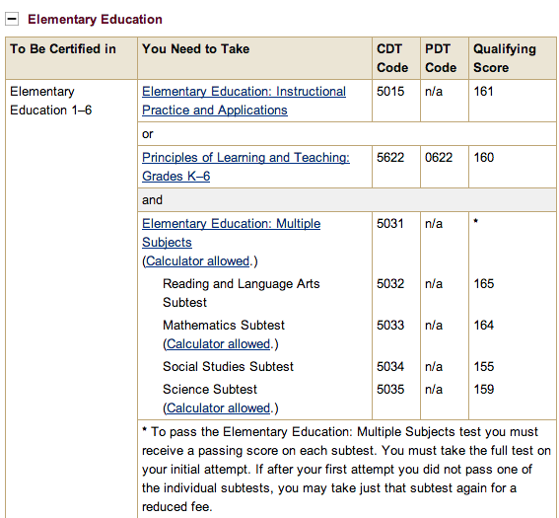

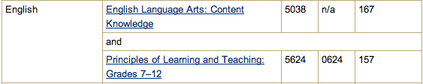
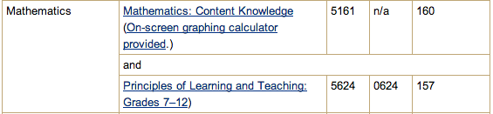
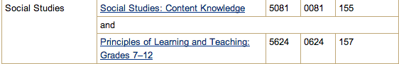
- ETS website is http://www.ets.org.
- If you need special accommodations for the PRAXIS tests, you need to request those accommodations four (4) weeks prior to registering for the tests.

PRAXIS II tests are available in paper-and-pencil format and computer-based testing format. ETS takes 6-8 weeks to report scores to universities, so make sure you take your PRAXIS II test(s) at least two months before your scores are needed: take your PRAXIS II pedagogy test by February or the middle of March if you want to apply for a teaching license right after you graduate in the middle of May.
When your scores are delivered to you (either hard or electronic copies), save them on your computer immediately. (I would recommend scanning in the hard copy so that it can be E-mailed. The digital copy needs to be saved from your ETS account also as it is available on the internet only for a limited time.)

NOTE:
- CUA must have all your licensure test scores, so mark CUA as a score recipient when you register. If DC’s OSSE is an option, mark them also.
- ETS must receive your completed registration form and payment by the appropriate date, or you will be charged a $40 late fee.
- Not all test centers are open on all test dates. Refer to the Test Center List page.
- You can get your scores in your account or by phone by calling 1-877-ETS- TEACH ($20 per report). You will need to have your DOB, test date, and SSN for purposes of validation.
- Please check deadlines for registration. Register early.
- It is possible to register for PRAXIS II as standby after the registration deadline. Those wishing to take the test as standby need to call ETS at 609-771- 7395 one week before the scheduled time of the test.
License Application
OSSE website for Educator Licensure Services:
http://osse.dc.gov/service/educator-licensure-services

More specific information about teacher licensure:
http://osse.dc.gov/service/teacher-licensure

This document includes information for the following licenses:
- Regular II (valid for 4 years, renewable) (standard license)
- Regular I (valid for 2 years, non-renewable) (used to be called provisional or temporary license)
- Endorsement License

- Standard (Regular II) license

A. Requirements (valid for 4 years, renewable)
- Complete program (courses and all field experiences with at least a C-) -Bachelor’s degree or GTCP program completion
  - Please note that Master’s candidates can apply for a teaching license after completing the GTCP portion (including student teaching/capstone experience) of their Master’s degree.
- *Pass PRAXIS CORE/CASE reading, writing, and math tests
  - Please note that if you have already taken the PRAXIS I PPST reading, writing, and math tests, they are valid until 8/31/16 only. New students MUST take the new PRAXIS CORE/CASE reading, writing, and math tests, and no alternative test scores on the GRE or SAT are accepted by DC’s Office of the State Superintendent of Education (OSSE) anymore.
- *Pass PRAXIS II content and pedagogy tests

*Always mark CUA as a score recipient. If DC or OSSE or DCPS is an option, mark it as a score recipient too so that the office receives your scores from ETS directly.

The Teacher Education Office now requires that graduating candidates submit a copy of their full ETS report (with sub scores) in order to be eligible for licensure.

B. Procedure for Submitting the License Application Packet
The following documents/materials must be included in your packet that you submit to OSSE:
- Completed license application form called “Application for Initial District of Columbia Educator License”
http://education.cua.edu/res/docs/License/Application-for-DC-Educator-License-REGULAR-II-S12.pdf
- $50 money order
- FBI check results (see description below)
- PRAXIS CORE/CASE (or PRAXIS I PPST or equivalent GRE/SAT scores for candidates who began their programs prior to Fall 2013)
  - Note that PRAXIS I PPST reading, writing, and math tests are valid until 8/31/16 only.
- PRAXIS II content and pedagogy passing test scores

Submit completed application packets to: Office of the State Superintendent of Education, Educator Licensure and Accreditation Unit, 810 1st Street, NE, 5th Floor, Washington, DC 20002.

Please note that CUA’s Office of Teacher Education does not process your license. Once you graduate, the Office of Teacher Education submits a Program Completion/Licensure Recommendation Form to OSSE to confirm that you have completed CUA’s teacher education program. CUA’s Office of Teacher Education needs to include the following information on this form:
- Social Security Number (all candidates)
- Information on undergraduate degree (graduate candidates)
Please contact Ms. Melisa Darby (darby@cua.edu, 202-319-5801, 218 O’Boyle) to provide this information.

Once OSSE receives your complete application packet, your teaching license will be processed in 12 weeks. If you need - for interview purposes - verification that you have completed a CUA teacher education program and are eligible for a teaching license, you can submit a request to the Office of Teacher education for a college verification form that will provide this information until you obtain your license from OSSE.

C. Background Check
Everyone applying for a DC license must obtain a national background check from the FBI.
See OSSE’s website for Procedures to Obtain Nationwide Criminal History Report (for DCPS Employees):
http://osse.dc.gov/sites/default/files/dc/sites/osse/publication/attachments/Criminal%20History%20Report%20DCPS%20employees_8.pdf
See OSSE’s website for Procedures to Obtain Nationwide Criminal History Report (for Non-DCPS Employees):
http://osse.dc.gov/sites/default/files/dc/sites/osse/publication/attachments/Non-DCPS%20Employee%20Background%20Check_7.30.2013.pdf
If you’re a non-DCPS employee, start the paperwork 3-4 months prior to completing your degree so that you have the background check results by the time you submit your license application form. (Please note that your FBI background check results are valid for only 12 months.) Submitting your FBI check results late will delay the process of licensure issuance.

Background Check Requirements and Resources:
http://osse.dc.gov/sites/default/files/dc/sites/osse/publication/attachments/Non-DCPS%20Employee%20Background%20Check_7.30.2013.pdf

Procedure for Requesting Your FBI Criminal History Record:
http://osse.dc.gov/sites/default/files/dc/sites/osse/publication/attachments/Criminal%20History%20Report%20all%20other%20applicants_8.pdf

- Complete the Applicant Information Form (http://www.fbi.gov/about-us/cjis/criminal-history-summary-checks) to request a review of your own record (DC does not have an agency number, so the process of sending the results to an agency number is not an option).
- Supply a legible fingerprint card to the FBI (see URL in #1 for possible fingerprinting agencies; best if completed on cardstock paper at http://education.cua.edu/res/docs/Fingerprint%20Card%20Application.pdf). Information on where to send your fingerprint card is on the Applicant Information Form.
- Have the background check results mailed to you (do not have them sent to the OSSE or CUA office directly).
- Put your results in a sealed envelope and include this envelope in your licensure application packet.

Additional Information on FBI Background Check:

http://www.fbi.gov/about-us/cjis/criminal-history-summary-checks

D. Interstate Agreement (Reciprocity)
If you plan to obtain a license in another state, contact the state where you are planning to teach to learn what other requirements you need to fulfill to receive a standard license from that state (once you have your standard license from OSSE). These requirements may include 1-2 professional tests (PRAXIS or other) and possibly a course (or more). With your DC license you are entitled to a Regular I (provisional) license in the states that have a reciprocity agreement with DC (see below). You can either wait to graduate and receive your DC license before you fulfill your other state requirements, or you can be proactive and meet these requirements while you are completing your CUA program. In the latter case you may be eligible for a standard license from your new state soon after your graduation.

Interstate (Reciprocity) Agreement for Standard License

http://osse.dc.gov/service/interstate-licensure-agreement-reciprocity

Teacher
Alabama  Arizona  Arkansas  California  Colorado  Connecticut  Delaware  Florida  Georgia  Hawaii | Idaho  Illinois  Indiana  Kansas  Kentucky  Louisiana  Maine  Maryland  Massachusetts  Michigan  Mississippi  Montana | Nebraska  Nevada  New Hampshire  New Jersey  New Mexico  New York  North Carolina  North Dakota  Ohio  Oklahoma  Oregon | Pennsylvania  Rhode Island  South Carolina  Tennessee  Texas  Utah  Vermont  Virginia  Washington  West Virginia  Wyoming

- Regular I (Provisional License)
This license is an option for those candidates who are just starting a teacher education program and are hired as a teacher of record in a DC elementary, middle and/or high school. Thus they need a Regular I “provisional or temporary” license until they complete their teacher education program and qualify for a standard Regular II license.

A. Requirements for Regular I (Provisional License) (valid for 2 years, non-renewable)
- Bachelor’s Degree
- Verification of current enrollment in a state approved teacher preparation program
http://osse.dc.gov/sites/default/files/dc/sites/osse/publication/attachments/Application%20for%20Regular%20I%20License.pdf
- Verification of current employment as a teacher in a DC local education agency
  - If the candidate is employed by a public charter or private school in D.C., the candidate will complete the appropriate section of the F-4 form and will ask the employing school to complete the teaching assignment section. The candidate submits the F-4 application to the Office of Teacher Education so that the teacher program and testing information can be added. Then the Office of Teacher Education sends the F-4 application to OSSE.
  - If the candidate has a teaching assignment with DCPS, OSSE has an established process to acquire the teaching assignment information from the DCPS HR unit.
- Passing scores or equivalents for all portions of the PRAXIS CORE/CASE
- Passing score for the Praxis II content knowledge exam in the subject area of the approved program (not required for ELL and Special Education teachers until Regular II application submission)

B. Procedure for Submitting License Application Packet
Submit the following documents to the Office of Teacher Education (not OSSE):
- A completed F-4 application form http://osse.dc.gov/sites/default/files/dc/sites/osse/publication/attachments/Application%20for%20Regular%20I%20License.pdf
  - Page 1: Candidate fills out
  - Page 2: CUA fills out
  - Page 3: Read Application Submission Guidelines and Documentation Checklist
- $50 money order
- An official copy of your arrest and criminal history record that has been issued within the previous 12 months.

Submit completed packet to: CUA’s Office of Teacher Education. Once your packet is processed, the Office of Teacher Education will send your packet to OSSE.

C. Background Check

Current DPCS employees and those being hired by DCPS (who have completed the fingerprinting process) may obtain clearance records from the DCPS Office of Human Resources. Otherwise, please visit OSSE’s website for instructions regarding Criminal Background Procedures for All Applicants.

- Endorsement License
According to a DC regulation, candidates who complete a state- approved program (all CUA TE programs are state approved) can apply for a teaching license in an endorsement area if they pass the required PRAXIS II content and pedagogy tests in the new area. For instance, early childhood education majors can apply for an elementary license also as long as they pass the elementary PRAXIS II content and pedagogy tests.

Use the F-5 Application for Teaching Endorsement at http://education.cua.edu/res/docs/kd-6-f5-osse-teaching-endorsement-app-vf-6-14-10.pdf if you plan to obtain licenses in additional areas in which you did not complete a program but passed the required PRAXIS II content and pedagogy tests.

Additional information can be found on the OSSE website at http://osse.dc.gov/service/obtaining-teaching-endorsement-licensure

Miscellaneous Information
- ARP, EP, and ST-ing evaluation
- Alumni Survey on the EP presentation day (Ms. Neely will give you the URL for the survey.)
- For employment: Check with the state where you are planning to teach whether you need to get a child abuse clearance, drug test, or any other criminal background check and if yes, when. (You may not be allowed to enter a class without these checks, and it may take up to several weeks to receive the results of the fingerprinting.)
- Impact of personal photos/videos on internet
- Keep in touch. Tell us who your employer is, what your non-CUA E-mail address is, and please become our fan on Facebook! (Department of Education at The Catholic University of America)
- We can discuss your educational progress with your parents only if you give us permission to do so. If you want to give permission, please do the following:
    - Obtain the Education Record Release Form at http://enrollmentservices.cua.edu/res/docs/Education-Record-Release-Form.pdf and
    - Submit the completed form to the Registrar’s office.

Disability Support Services – Policy for Candidates Registering for Field Experiences
If you are a teacher education candidate (in early childhood, elementary, or secondary education) and have a disability, we encourage you to inform Dr. Agnes Cave, Director of Teacher Education (cave@cua.edu) or Ms. Elsie Neely, Director of Field Experiences (neely@cua.edu) of your disability so that we can best help you in terms of accommodations that you may need for your field experience. We further encourage you to coordinate with the office of Disability Support Services to ensure you obtain support for completing the program. If you choose not to reveal this information, understand that there are consequences for that decision. Accommodations are not retroactive. Please visit the DSS website at http://disabilitysupport.cua.edu for additional information.

